**Final Project - Econ 5529**

Chloe Segale

12/17/2017

~OPTION~

**Manufacturing sector:**

growth as a function of sales: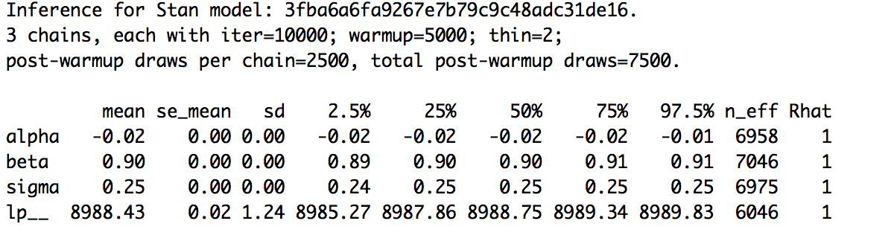

(beta is p)

Gibrat’s law is not probable because beta (p) does not equal one

posterior mins vs actual min



posterior max vs actual max



posterior sds vs actual sds

centered



actual sd (to right) not even close:



predicted data:



compared to predicted data:



again, gibbs law is not probable after reviewing the data.

**growth as a function of total assets (to measure robustness)**

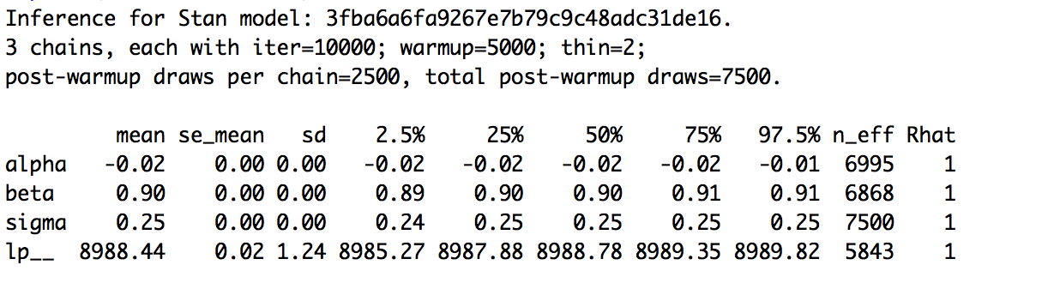

for comparison growth measured by sales

by company code(gvkey):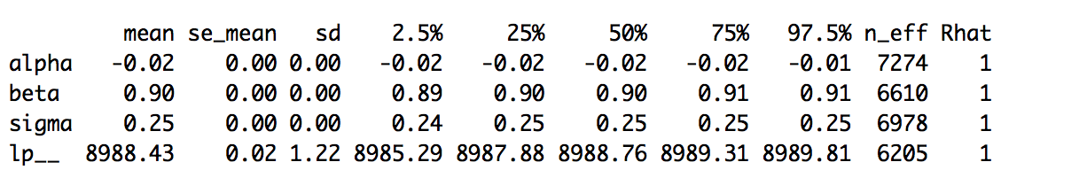

based off of these priors, the model does not appear to be robust.

**RETAIL TRADE**

(growth measured by sales)

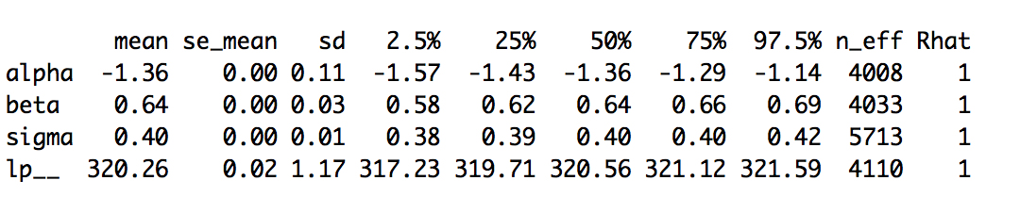

Gibrat’s law is again proven to be even less probable in the retail trade sector.



[retail trade] growth measured by total assets:

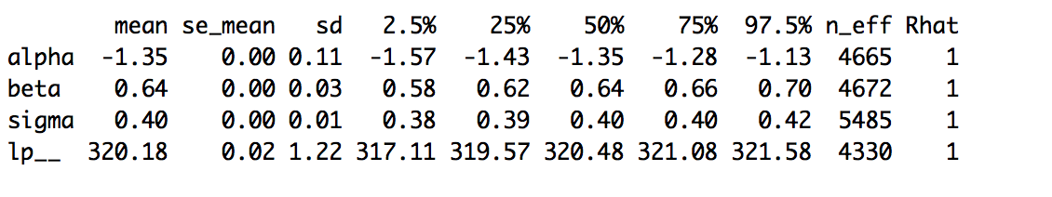

[retail trade] measured by gvkey

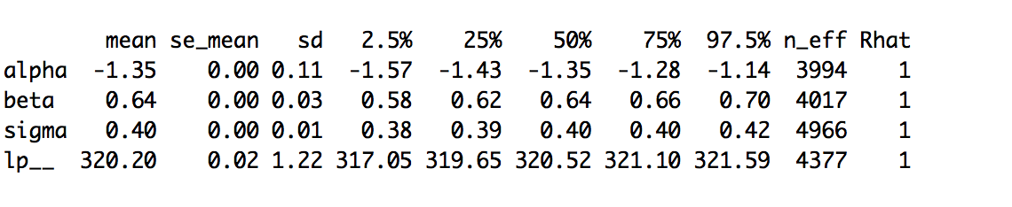

Gibrat’s law is unsupported by the evidence – p does not equal 1 in any of the above scenarios. The model is not robust between sales, total assets, or gvkey but does appear to be robust between sectors.